Dear !!!name!!!,

Halloween season is about to come and we are happy to announce that Angels Fancy Dress has the largest selection of fancy dress costumes in the UK.

With a great choice of costumes and accessories for Adults and Kids there is a lot for you to promote.

Here is our Halloween bestsellers...

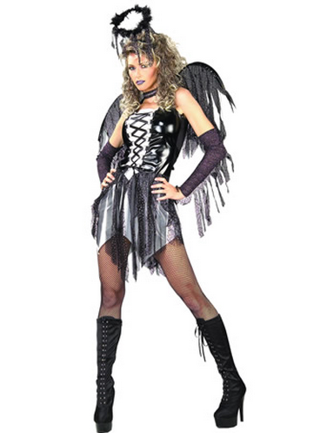

<http://www.awin1.com/cread.php?awinmid=2610&awinaffid=!!!id!!!&clickref=&p=http://www.fancydress.com/costumes/Fallen-Angel/0~345314~264>

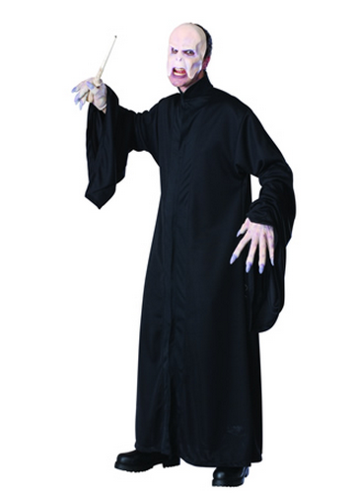

<http://www.awin1.com/cread.php?awinmid=2610&awinaffid=!!!id!!!&clickref=&p=http://www.fancydress.com/costumes/Voldemort-Adult-Costume/0~267557~267>

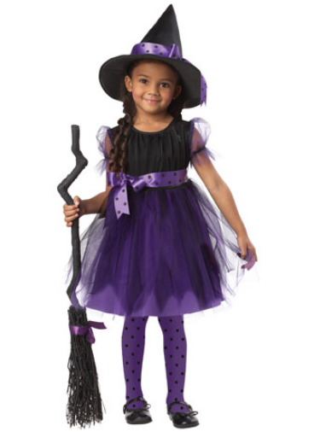

<http://www.awin1.com/cread.php?awinmid=2610&awinaffid=!!!id!!!&clickref=&p=http://www.fancydress.com/costumes/Charmed-Witch-/0~4342987~43>

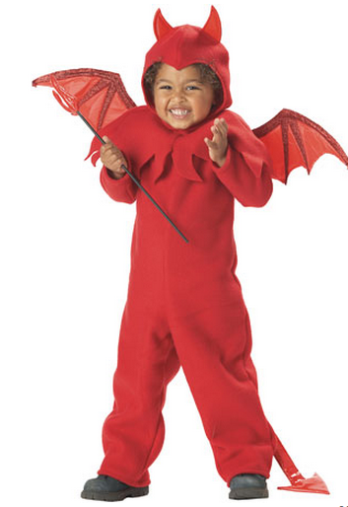

<http://www.awin1.com/cread.php?awinmid=2610&awinaffid=!!!id!!!&clickref=&p=http://www.fancydress.com/costumes/Lil-Spitfire-/0~1266892~43>

You can find plenty of capes, masks and accessories here:

<http://www.fancydress.com/costumes/Halloween-Accessories/2~76~7>

Finally, below are CTA images for your marketing campaigns.

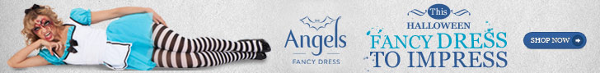

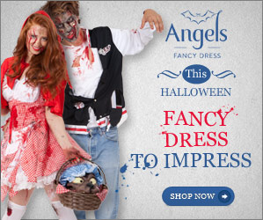

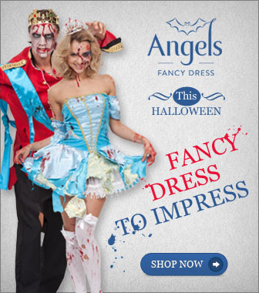

Best Wishes,  
The Angels Fancy Dress Affiliate Team.